Lab Manual -- Attach Data Volume to existing Windows EC2 instance.

Steps
- Create the Windows EC2 instance
- Attach the volume to the EC2 instance from the AWS console
- Format and mount the volume inside the Windows Machine.
- Detach the Volume from the Windows Machine.

- Create the Windows EC2 instance

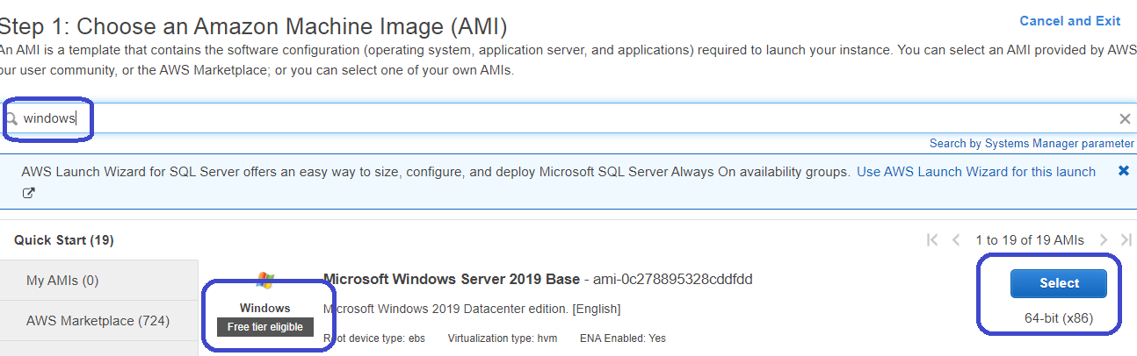
Search for windows machine and select the one with “Free Tier”
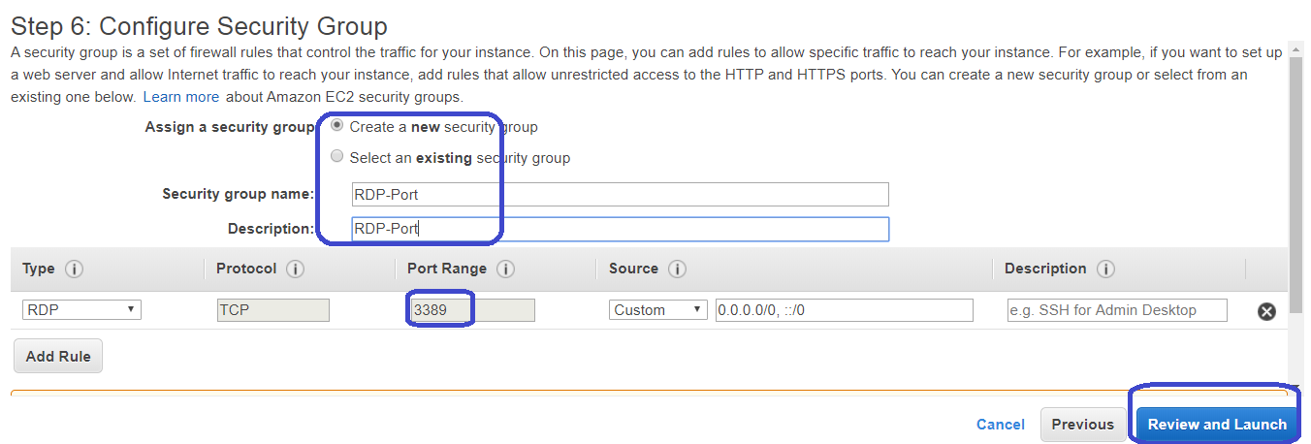
Make sure to create an new Security Group, in case its not available with port rdp (3389)

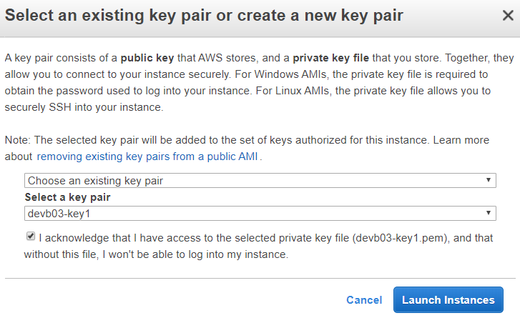
We could use the same Key , that was used for the linux machines previously.

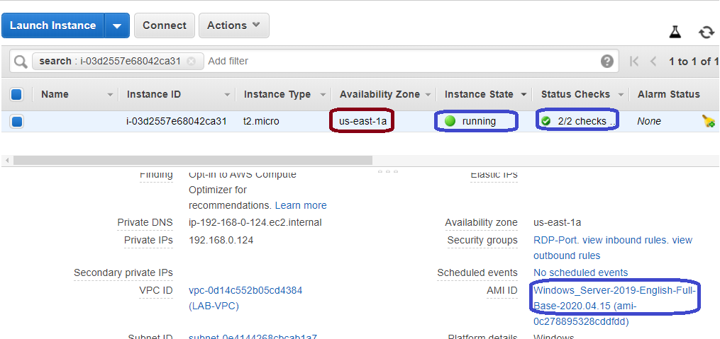
The windows Ec2 instance is created in the “us-east-1a”, we would need to create the volume as well in the same Availability Zone.
Lets login to the windows machine, chk the disk mgmt..
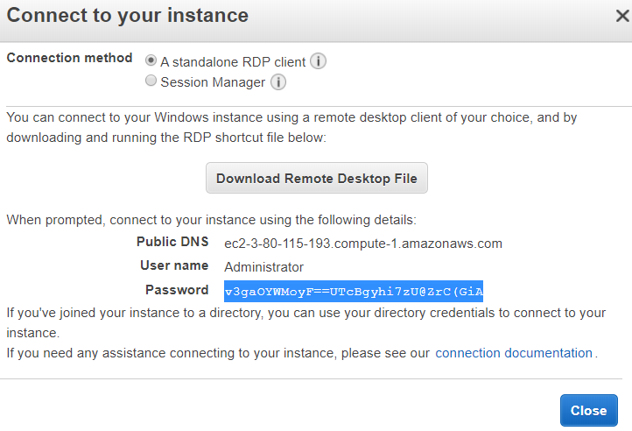
You need to “get the password” to login to the windows machine.

Login to the windows machine.

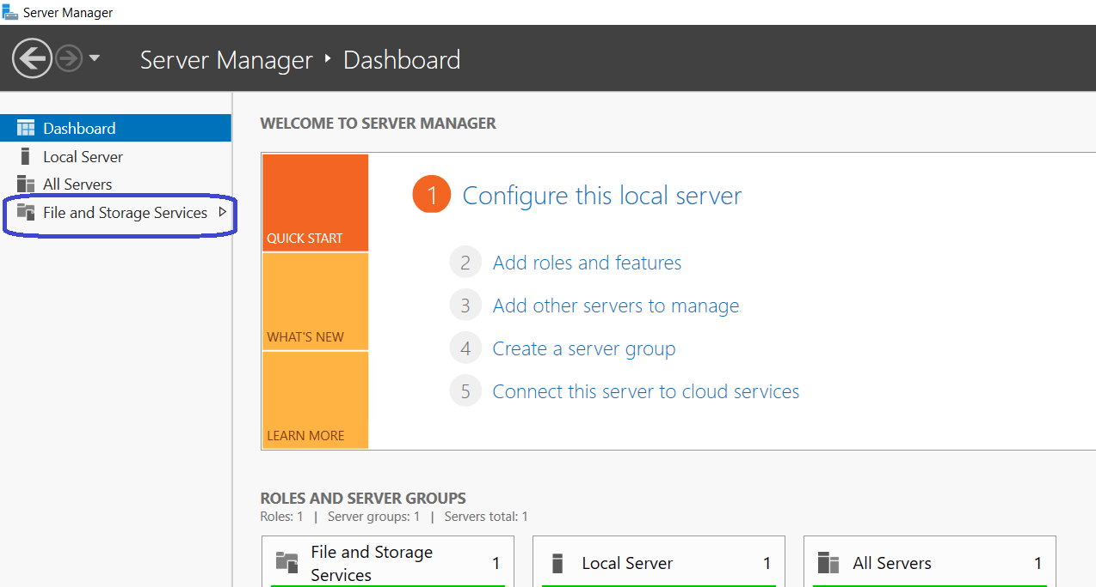
Open the “server Manager” and wait for it come up.
Click on “File and storage Service”

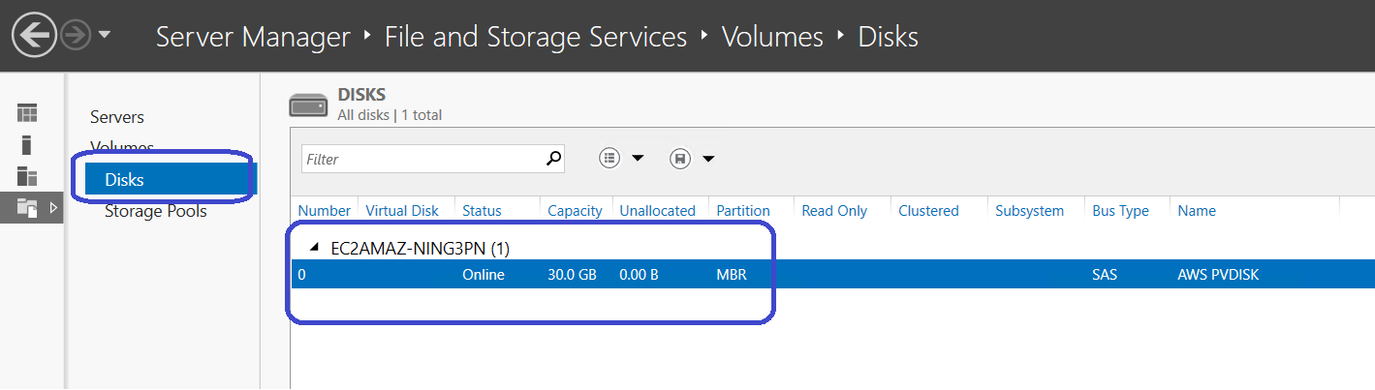
And then Click on “Disks”.
Currently we would see only the c drive of 30 GB.
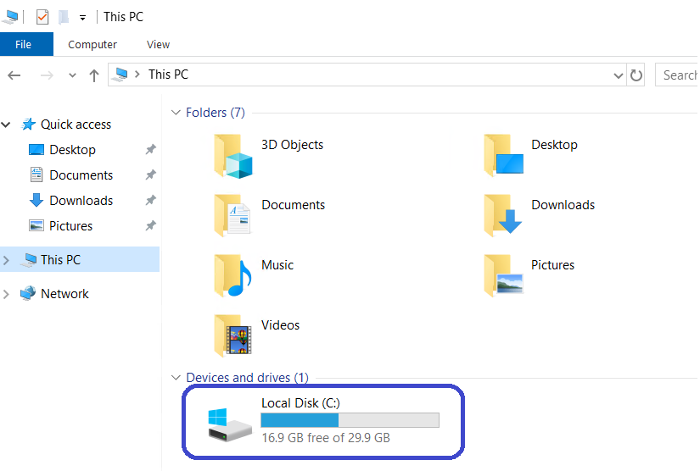
Which means currently we have only one virtual disk of 30GB, which is the OS disk.
Now, lets attach the new empty volume to this windows EC2 instance.

- Create & Attach the volume to the Windows EC2 instance from the AWS console.
Note: -- Assuming the Volume and the EC2 instance are in the same “Availability Zone”
Click on “Volumes” on the left panel under EC2 page.
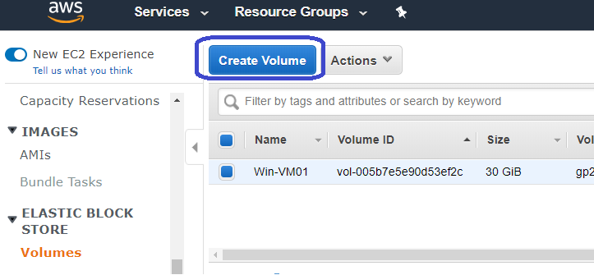

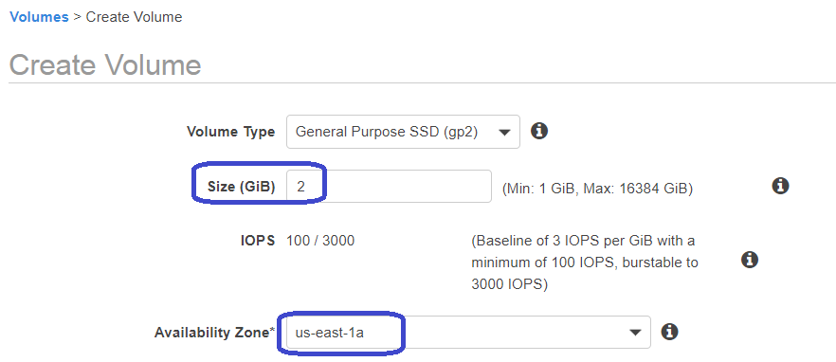
We will create a 2GB volume, in the same Availability Zone.
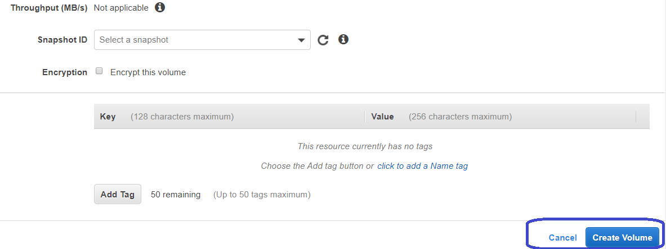
DO NOT SELECT ANY “SNAPSHOT”, LEAVE IT EMPTY.
Click on “Create Volume”
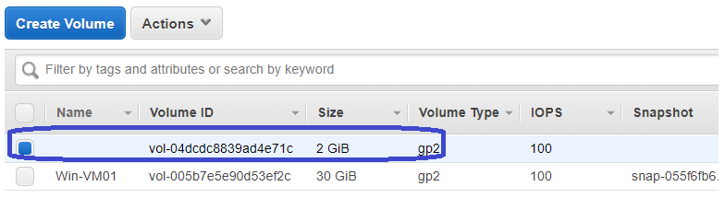
The new volume is created for 2GB.
, now lets attach this to the EC2 instance.

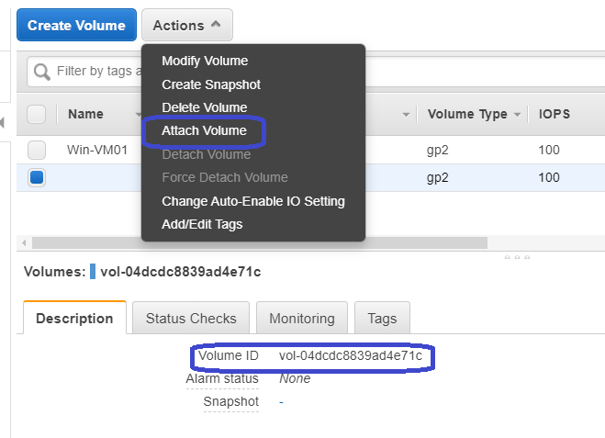
Select the Volume and Click on “attach volume”
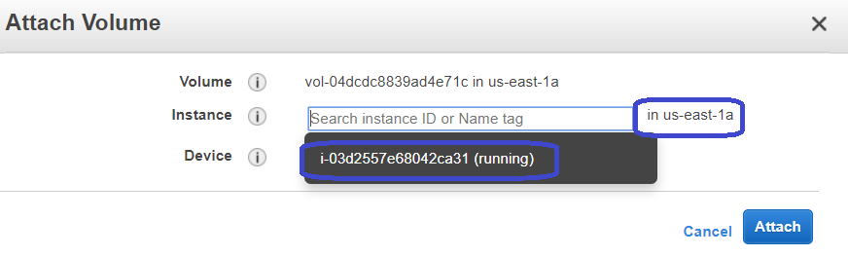
The windows instance would be listed to attach the volumes.
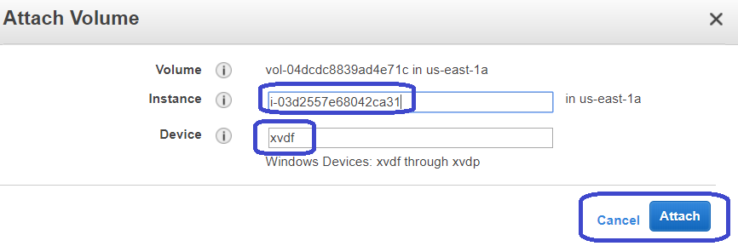
The volume get attached as “xvdf”.
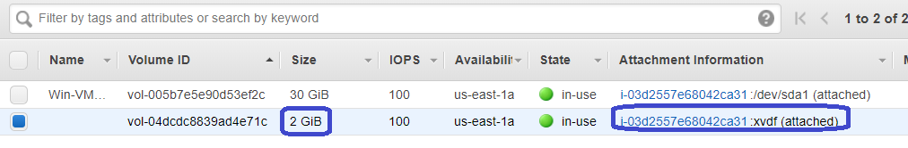
The “attachment Info” would show the instance details that it is attached to it.

- Format the volume inside the windows EC2 Machine.

Step 1:
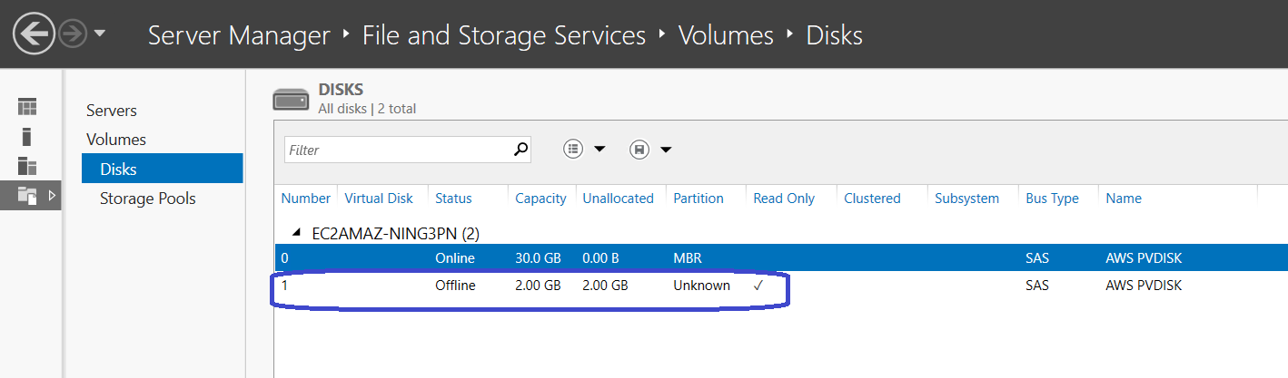
The disk mgmt. is now showing the “2gb Volume” that was created and attached.

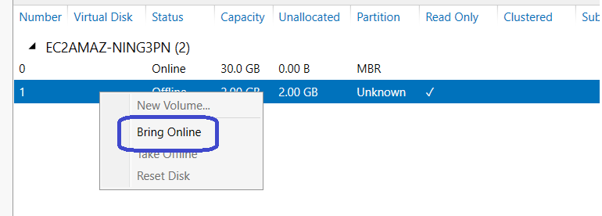
Right click on the new volume, and cLick on “Bring Online”.

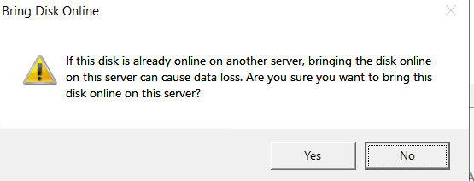

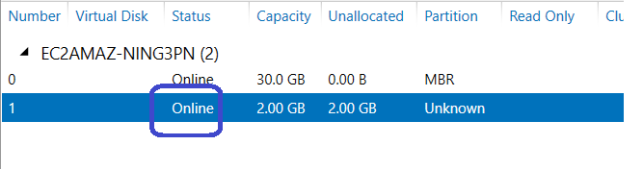
It would say “Online”

Let’s now format and create the drive.
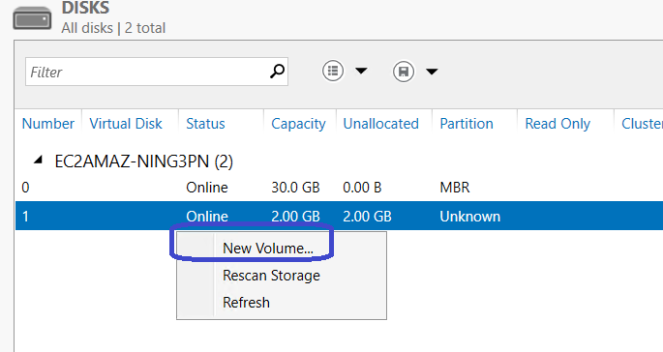
Right click on the new volume and click on “New Volume”.

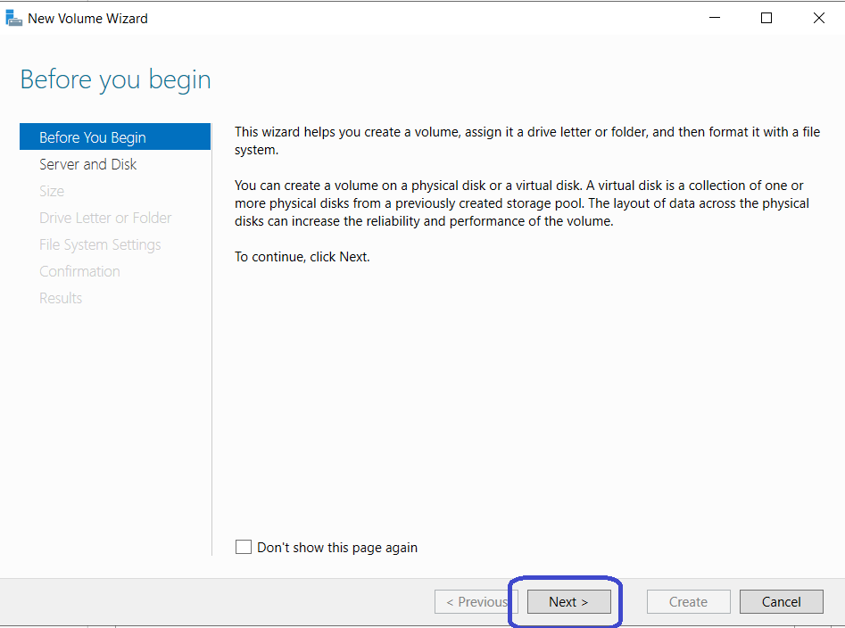
Click on “NEXT”

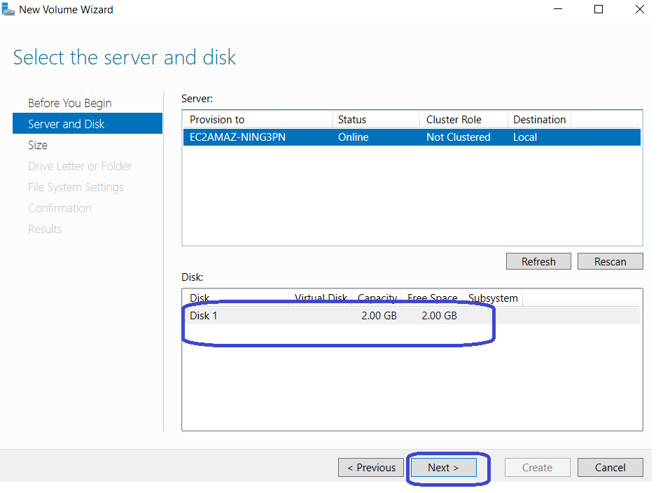
The 2gb volume is selected, now click “next”.
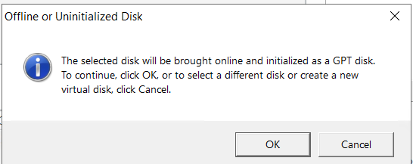
Click on “OK”. On the popup window.
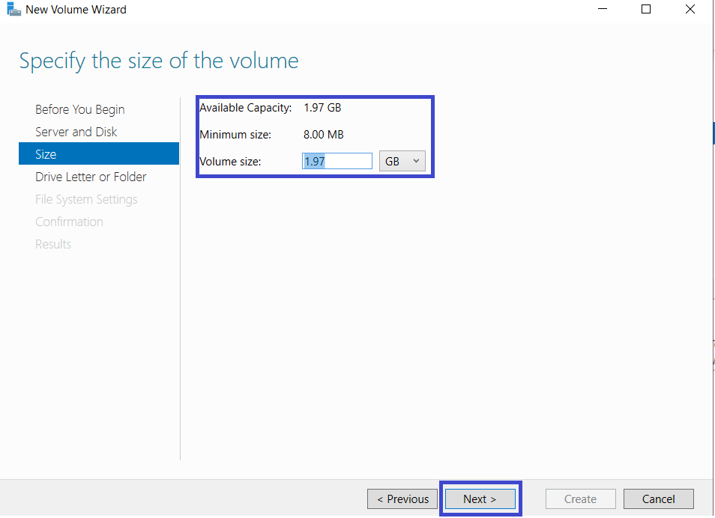
Click on “Next”

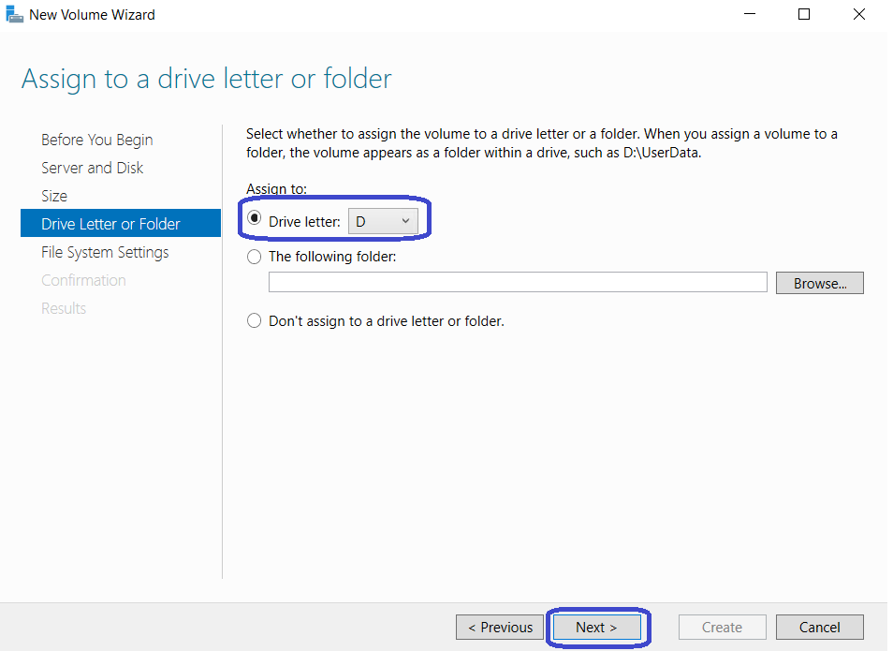
This would list the drive letter, just let it be in default.
And click “NEXT”.
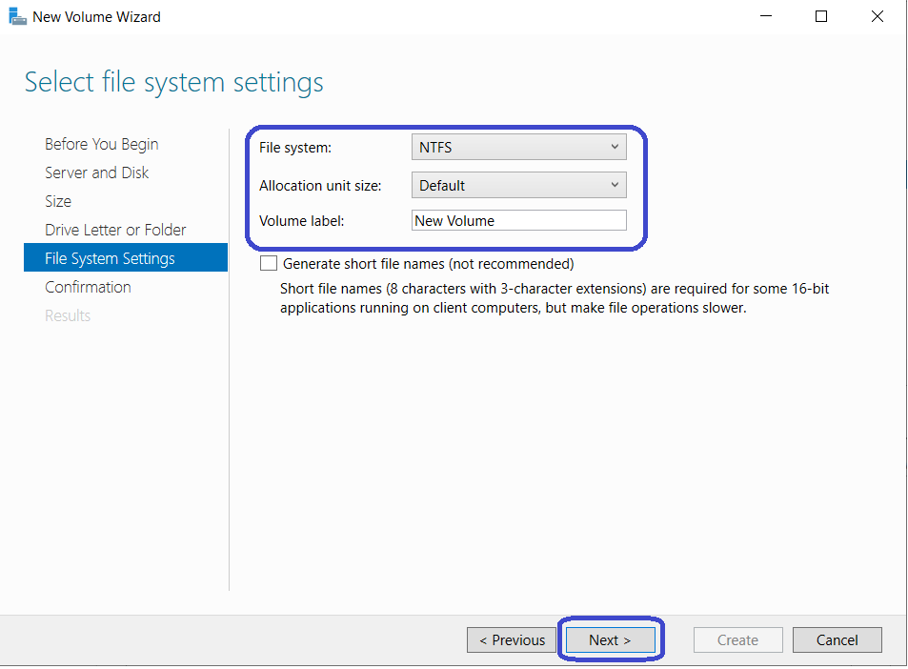
Click on “NEXT”.
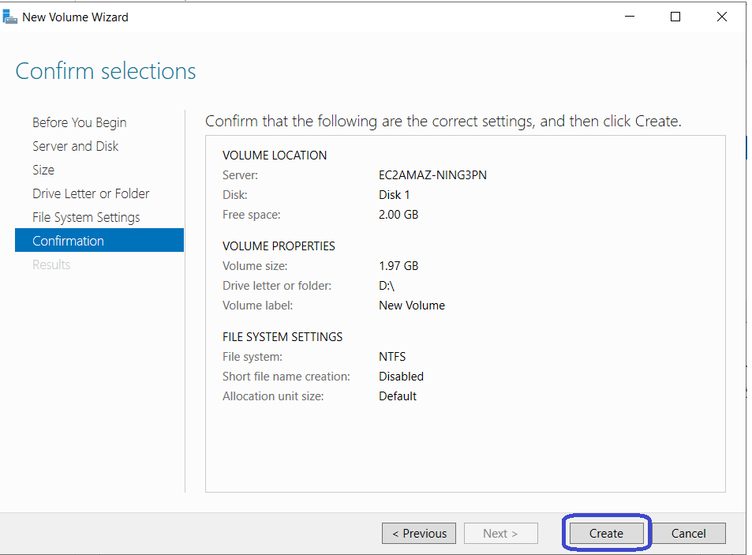
Click on “Create”.

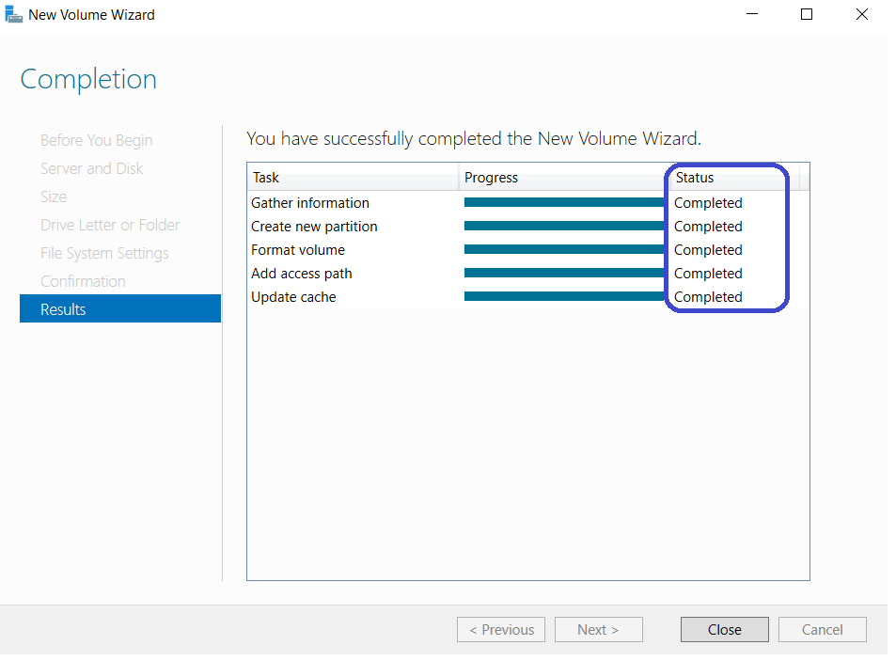
The Drive is successfully created.
Let’s check in the “Windows Explorer”
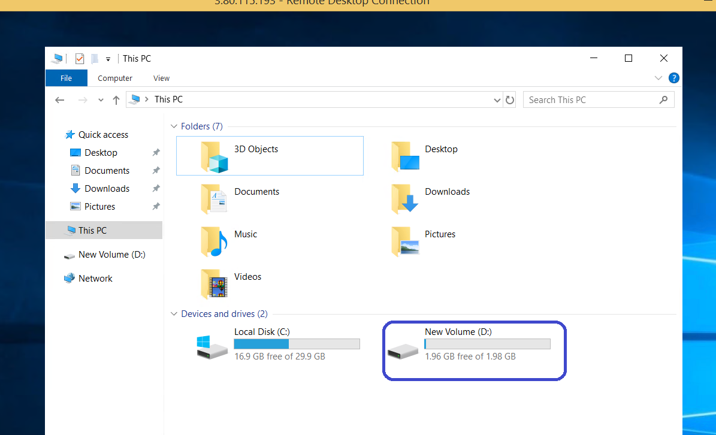

The new “2Gb Volume” is detected as D: drive.

- Detach the Volume from the Windows Machine.
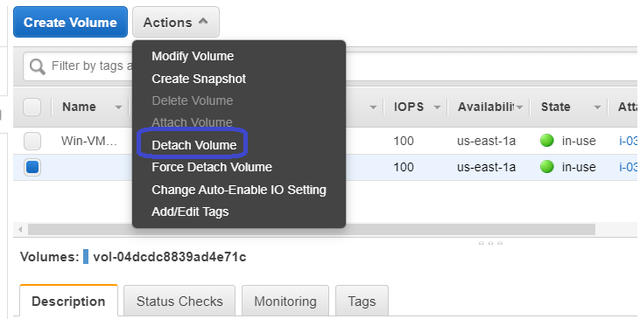
Select the volume and click on “Detach Volume”.
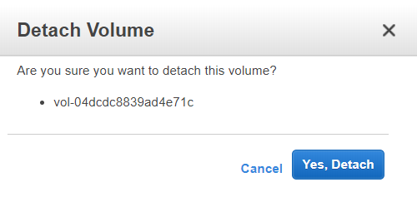
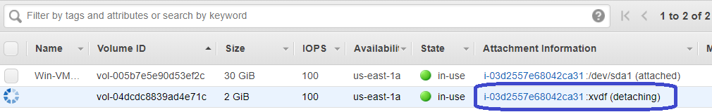
Its “detaching”.
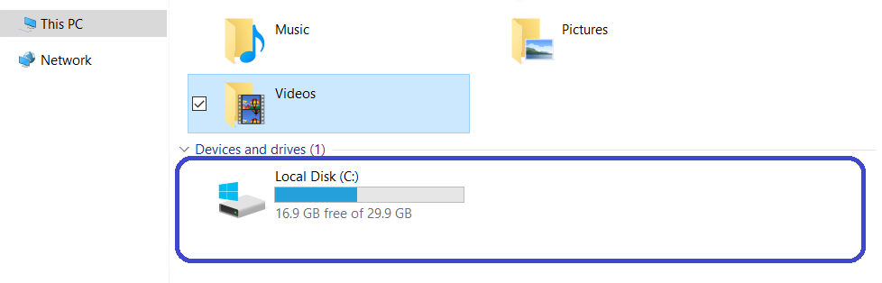
The “2Gb Volume” is disappeared. This means, we could detach the volume from windows at any given point of time.
- Delete the new volume
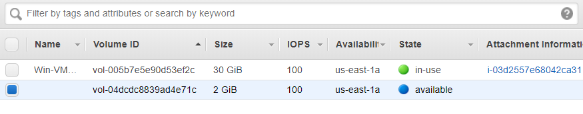
Once the volume says “Available”, its ready to get deleted.

